**Requirements**

**1, Create table SFIS1.C_API_CLIENT_T**

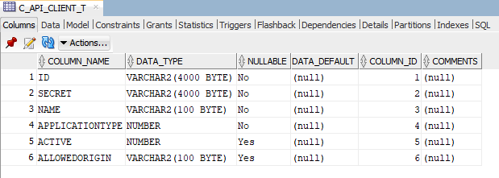

**2, Create table SFIS1.C_API_REFRESHTOKEN_T**

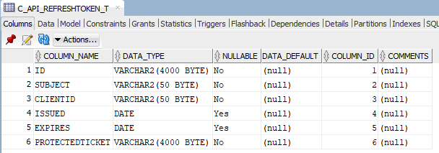

**3, Generate ClientSecurity id**

*3.1, Using tool ClientIdGenerate*



*3.2, Put data to SECRET column*

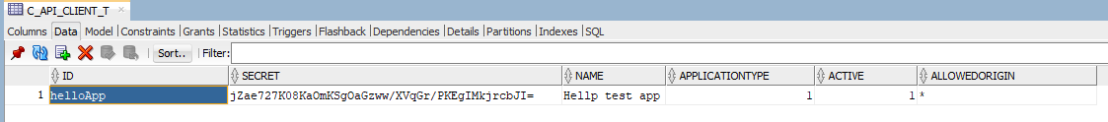

**SFIS1.C_API_CLIENT_T defitions:**

**ID: Application id**

**SECRET: Is hashed ClienSecret**

**NAME: Description**

**APPLICATIONTYPE: IS 0(Native) or 1(Nonative)**

**ACTVIVE: 1 Enable or 0 Disable**

**ALLOWEDORGIN: Native app shoud be “*” Nonative app please refer this link https://bitoftech.net/2014/07/16/enable-oauth-refresh-tokens-angularjs-app-using-asp-net-web-api-2-owin/**

**API developments**

Use 4 library to develop your application:

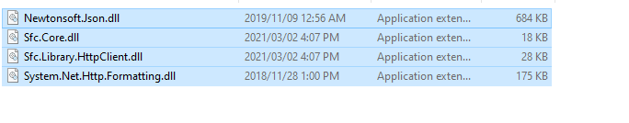

1, Class **SfcHttpClient** initialise

**baseUrl**: Web api server address

**dbKey**: Oracle database connection string define in Web.config in web api server

**clientId**: Your App ID define in **SFIS1.C_API_CLIENT_T**

**clientSecret**: Client Secret non hashed(ex: 123456) define in **SFIS1.C_API_CLIENT_T**

**autoRefreshToken**: Auto get token when token expires, default true

2, **SfcHttpClient** funtions

**GetAccessTokenAsync**: get token take 2 argument username and password

**GetRefreshTokenAsync**: get refresh token take 1 argument

**QuerySingleAsync**: take 1 argument QuerySingleParameterModel response a single data

**QueryListAsync**: take 1 argument QuerySingleParameterModel response list data

**ExecuteAsync**: take 1 argument QuerySingleParameterModel response list data if SfcCommandType is “**StoredProcedure**” and SfcParameterDirection is **InputOutput** or **Output** otherwise response data is null

3, class **QuerySingleParameterModel** description

**CommandText:** is your command dirsed execute accept both procedure and sql like INSERT, UPDATE, DELETE

**SfcCommandType:** Support **Text** | **StoredProcedure** | **TableDirect**

**SfcParameters**: take list of **SfcParameter** params

4, class **SfcParameter** description

**Name**: name of parameter

**Value**: Value of parameter

**SfcParameterDataType:** Data type of parameter

**SfcParameterDirection:** Direction of parameter

Example:

**GetAccessTokenAsync**:



**QueryListAsync:**

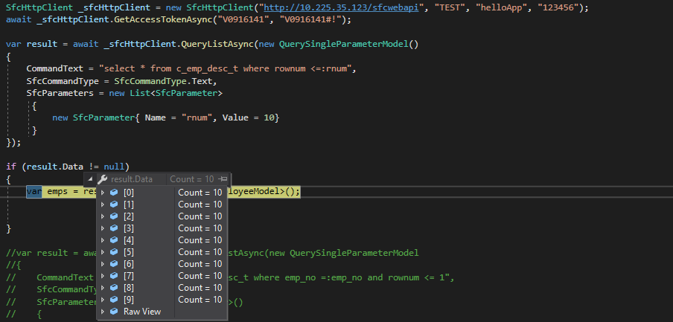

or you directly write command without SfcParameter

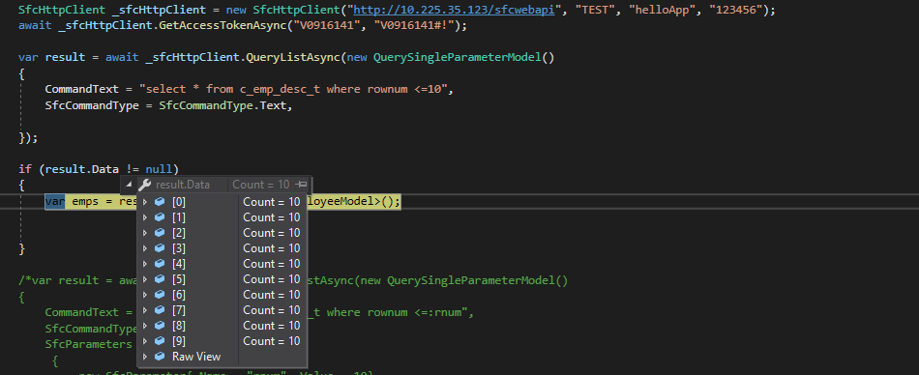

**QuerySingleAsync**:

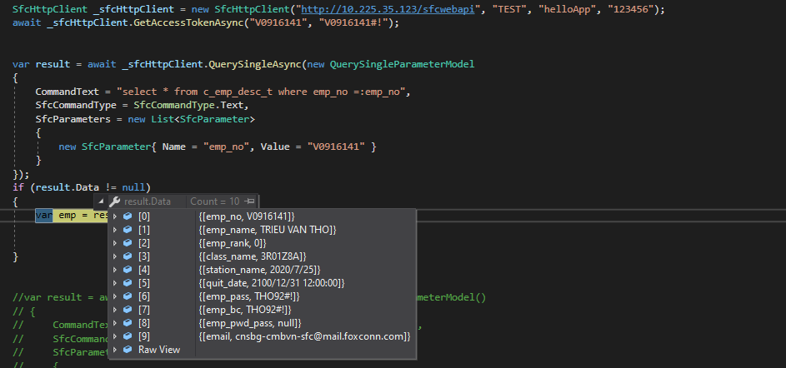

or

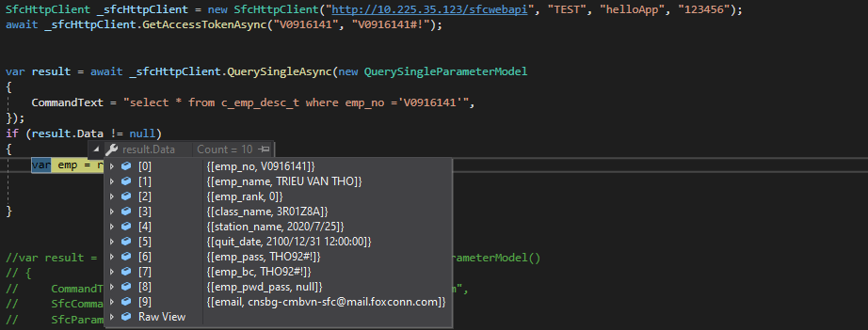

**ExecuteAsync**:

Execute procedure:

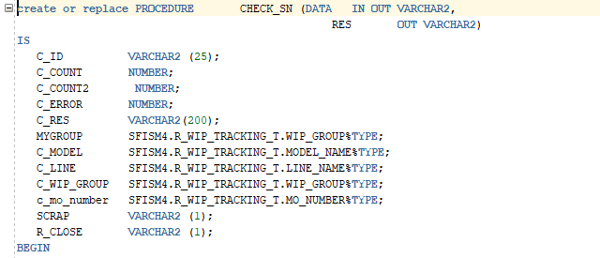

example procedure “CHECK_SN” taken 2 argument DATA(IN OUT) and RES(OUT)

Execute successfullu:

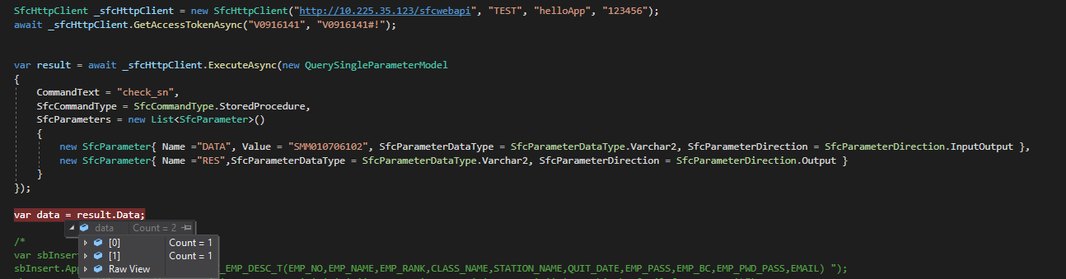

you can get output “DATA” as IN OUT data type

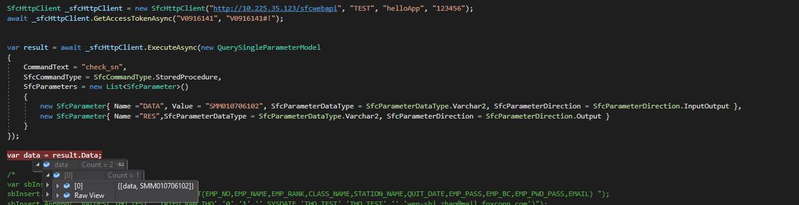

you can get output “RES” as OUT data type

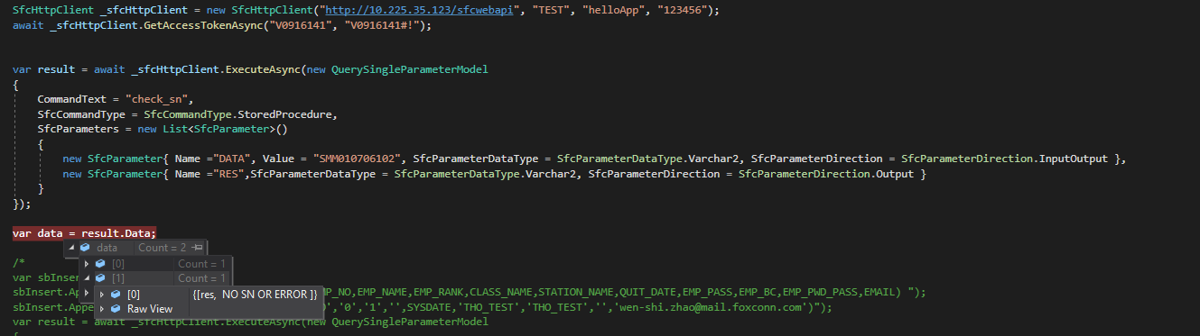

Execute error:

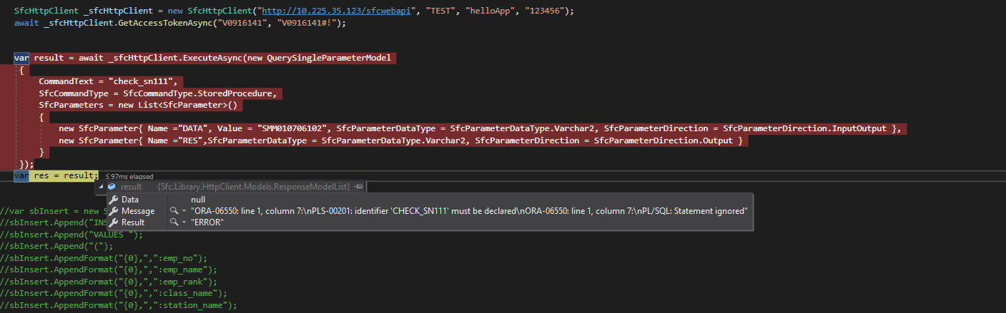

**INSERT**:

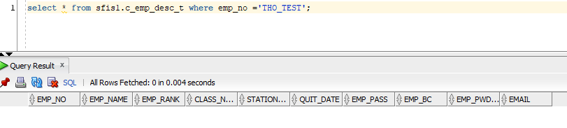

after:

inserted successfuly(result:”OK”)

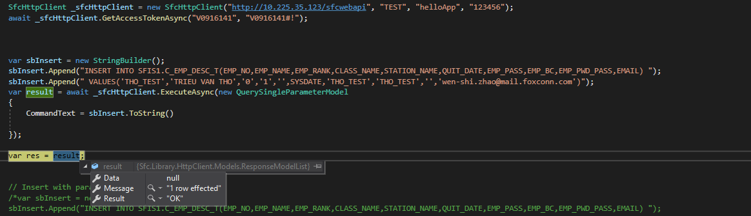

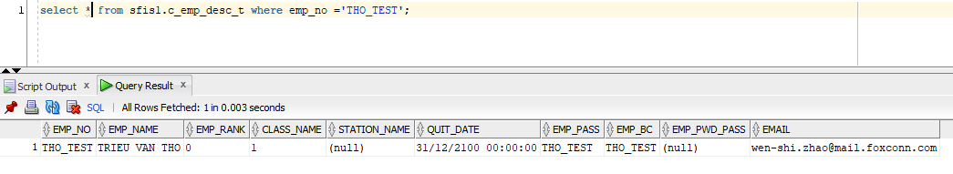

inserted fail(result: “ERRO”)

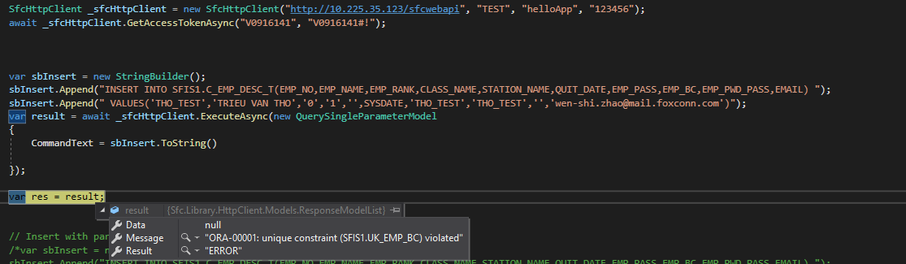

or you insert with parameter

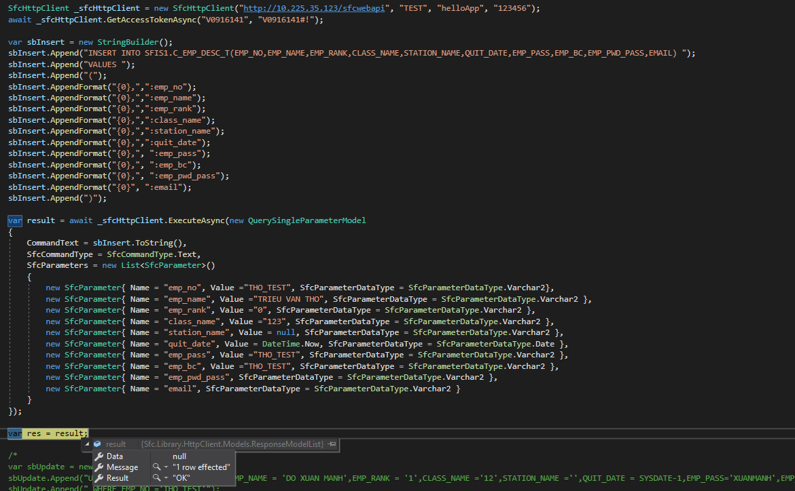

**UPDATE, DELETE** similar **INSERT** parameter